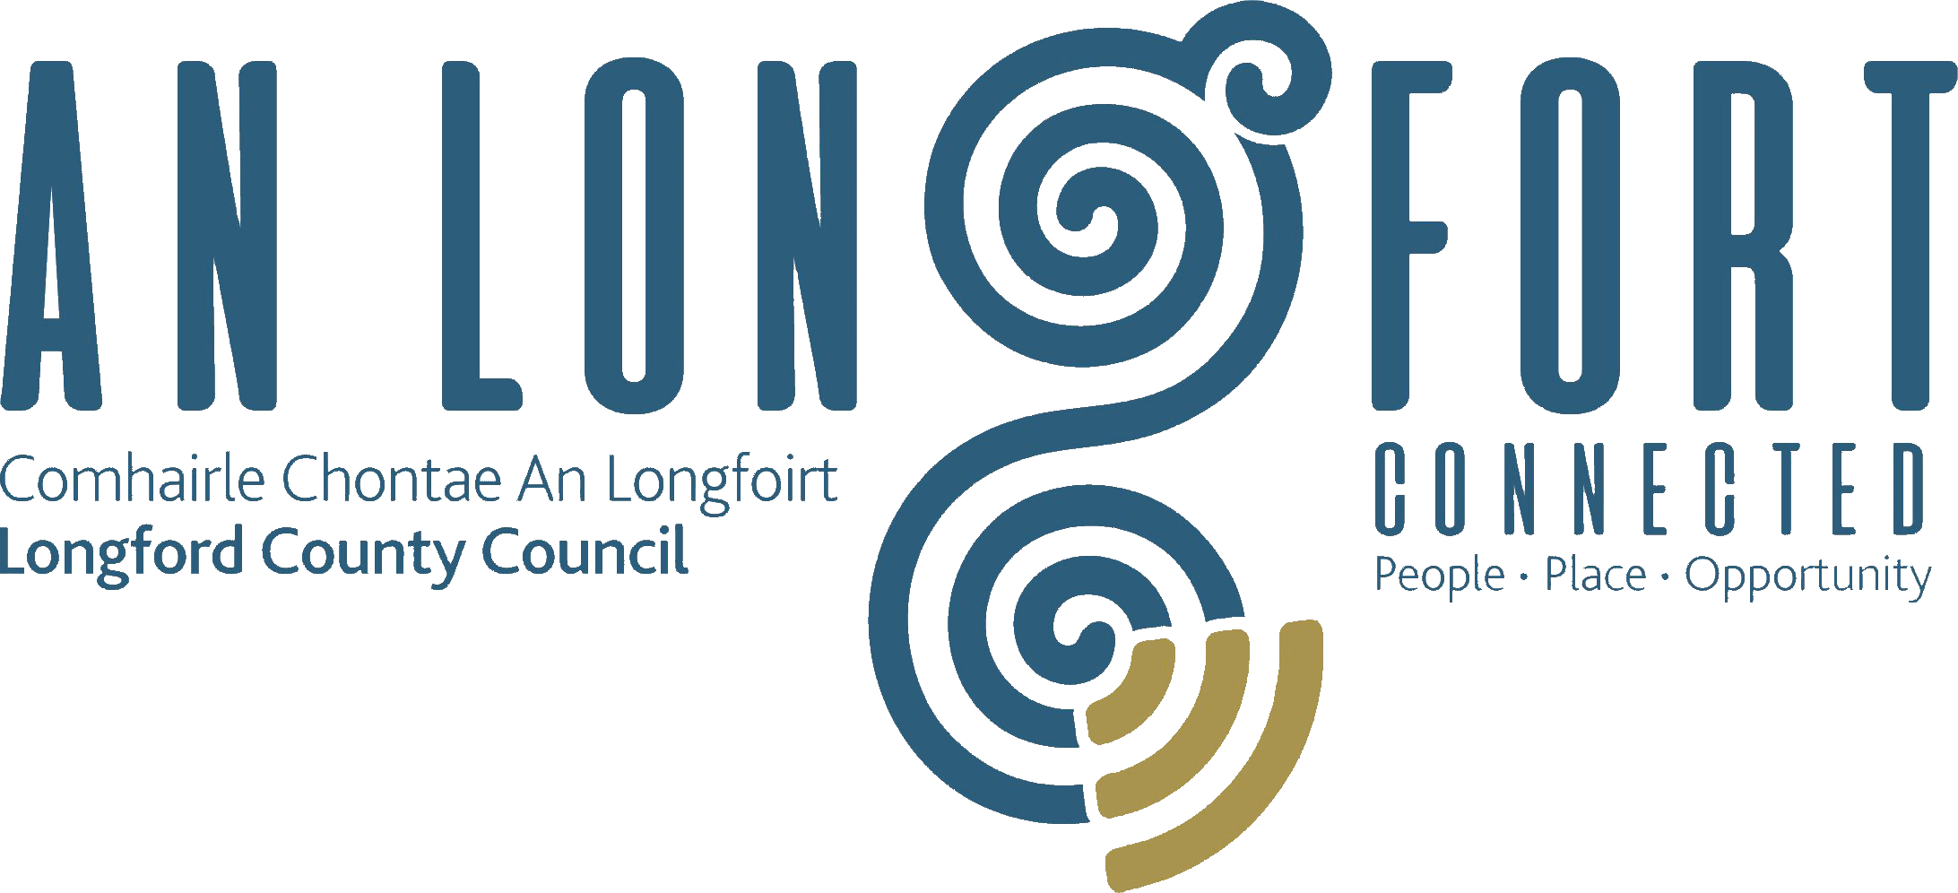

**STRATEGIC INFRASTRUCTURE**

**STRATEGIC POLICY COMMITTEE**

**Minutes of Strategic Infrastructure Strategic Policy Committee Meeting**

**held via Microsoft Teams**

**on Thursday, 2 February 2023 at 3pm**

**PRESIDING**: Councillor Colm Murray, Chairperson

**PRESENT**: Councillors – Pat O’Toole and Gerry Warnock

Maria Keelty, Tess Murphy and Stephanie Igoe

**IN ATTENDANCE:**  Ms. Samantha Healy, Director of Services

Mr. Terry Rooney, Senior Executive Officer

Mr. Con Diffley Senior Executive Engineer

Mr. David Tubridy, Senior Engineer

Ms. Martina McGrath, Administrative Officer

**APOLOGIES:** Fiona Fenlon

**MEETINGS**

**ADMINISTRATOR**: Claire McNabola

**ADOPTION OF MINUTES**

On the proposal of Councillor Gerry Warnock and seconded by Councillor Pat O’Toole, it was unanimously agreed to adopt Minutes of Strategic Infrastructure Strategic Policy Committee meeting held on the 20 October 2022, as circulated.

**MATTERS ARISING**

Councillor Gerry Warnock raised the matter of dog fouling around Longford town, and a need for additional bins. Samantha Healy will ask the Community Warden to ensure bag dispensers throughout the town are supplied with bags. Councillor Warnock said he would bring the matter of additional bins to the Longford MD for consideration.

Maria Kielty raised the matter of chewing gum. Samantha Health responded by saying she will indeed bring the matter to the attention of the Community warden for intervention and enforcement. In addition, both matters would require behavioural change and Samantha Healy will review with the Environment Officer with regards working with local schools.**.**

**DECLARATION OF INTERESTS**

None.

**HOUSING AND DISABILITY STEERING GROUP QUARTERLY REPORT**



**ROADSIDE MEMORIAL POLICY**

Con Diffley presented the draft Roadside Memorial Policy.

On the proposal of Tess Murphy and seconded by Councillor Pat O’Toole it weas agreed that the item be defered to the next meeting of the SPC to allow members time to read and share observations on the draft policy. The draft policy to be circulated to members after the meeting.

**CONFIRMATION OF DATE OF NEXT MEETING**

24April 2023

This concluded the business of the meeting.

**Signed:**

**Claire McNabola**

**Meetings Administrator.**

**Confirmed and adopted at Strategic Infrastructure Strategic Policy Committee Meeting held on the 17 April 2023.**

**Signed:**

**Chairperson.**